
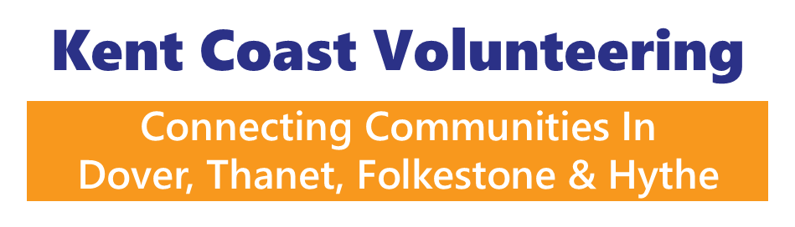

Would you like to be part of our exciting, new project?
Title: Communications Officer
Hours: 14 hours per week (flexible working to include a Wednesday when needed)
Fixed Term: 4 Years – generously funded by The National Lottery Community Fund
Salary: £10,733 per annum (pro rata of £26,832 full-time equivalent, based on a 35-hour week).
Location: Hybrid (working in the community, home and our Deal office)
Annual Leave: 11.5 days (pro rata of 28 days) plus bank holidays, volunteering days and a day off on your birthday.
Reporting to: Charity Manager

Working at Kent Coast Volunteering (KCV) is more than “just another job”, it’s a chance to be part of something that really matters with a team that truly cares. You probably already know us; we are a recognised brand in Thanet, Dover, and Folkestone & Hythe, supporting volunteers and Volunteer Involving Organisations (VIO’s) to respond to the challenges of social action, meet needs and improve quality of life.

Now, thanks to a 4-year award from The National Lottery’s Reaching Communities fund, we will reduce loneliness and isolation by bringing 700 people together through volunteering. We will create accessible, co-designed and supported volunteering pathways and support people into meaningful and accessible volunteering opportunities. We also support organisations to develop best practice in volunteering.
The Role: a pivotal new post to grow the visibility, reach and impact of volunteering across East Kent by sharing powerful local stories, promoting opportunities and celebrating the contributions of volunteers and community organisations. You will amplify the voices of marginalised volunteers, highlight inclusive practice, and ensure the impact of National Lottery funding is visible across our communities.
Key responsibilities: Storytelling & Communications; Promotion of Volunteering Opportunities; Celebrating Volunteers & Community Organisations; Digital & Media Development; Strategic Communications & Learning.
As well as offering a positive culture, we offer 11.5 days annual leave (pro rata of 28) plus bank holidays, volunteering days, a day off on your birthday and access to KCV’s Employee Assistance Programme.
- Applicants are invited to submit a CV and a covering letter outlining how they meet the Person Specification and why they are the right person for the role. We encourage you to address the role description in your answer.
- The Person Specification can be obtained by visiting [website].
- Please send your CV and covering letter to emma.cooney@kcv.org.uk by 9am on Thursday 27 August.
- Only shortlisted applicants will be invited to interview on Tuesday 1 September, so please keep this date free if possible.
- We aim to notify shortlisted candidates on Thursday 27 August.
Any questions, contact Charity Manager, Emma Cooney, at emma.cooney@kcv.org.uk or on 01304 367898 (next in the office on Monday 10 August - so may not be able to reply to your questions immediately).

