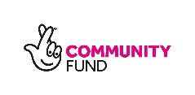
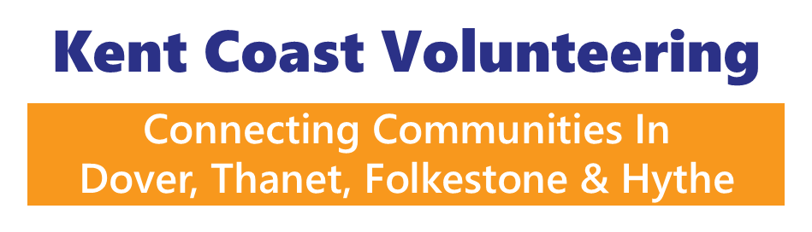
Job Title: Communications Officer
Location: East Kent (Thanet, Dover and Folkestone & Hythe districts – Deal office with some hybrid working with regular community-based work)
Contract: Fixed term, 4 years
Hours: 14 hours per week (flexible working to include a Wednesday when needed)
Salary: £10,733 per annum (pro rata of £26,832 full-time equivalent, based on a 35-hour week).
Responsible to: Charity Manager / Project Lead
Funded by: The National Lottery Community Fund

About Kent Coast Volunteering
Kent Coast Volunteering (KCV) connects communities through inclusive volunteering. We work across Thanet, Dover and Folkestone & Hythe, supporting voluntary, community, social enterprise and faith (VCSEF) organisations and hundreds of local residents each year.
We have launched a four-year programme funded by The National Lottery Community Fund, to transform the lives of more than 700 vulnerable and marginalised people across East Kent. The project will reduce loneliness, isolation and poor mental health by creating accessible, co-designed and supported volunteering pathways.

About our New Project
Our new project will proactively engage isolated and marginalised residents in areas including CT11, CT12, CT9, CT10 (Thanet), CT16, CT17 (Dover), and CT19, CT20 (Folkestone).
Over four years we will:
- Engage 712 residents (including 502 facing significant barriers to participation).
- Improve mental health and wellbeing (measured using SWEMWBS).
- Increase inclusion in volunteering for people facing poverty, disability, discrimination or isolation.
- Strengthen grassroots organisations to become more inclusive and welcoming.
- Promote a positive culture of volunteering aligned with the National Vision for Volunteering.
Our approach combines community outreach, buddying, taster sessions, adapted volunteering roles, co-designed social action, training, celebration and storytelling.

The Role
The Communications Officer is a pivotal new post. You will grow the visibility, reach and impact of inclusive volunteering across East Kent by sharing powerful local stories, promoting opportunities and celebrating the contributions of volunteers and community organisations.
You will amplify the voices of marginalised volunteers, highlight inclusive practice, and ensure the impact of National Lottery funding is visible across our communities.
Working closely with the rest of the team – the Community Connectors, the Volunteer Support Officer and Best Practice Coordinator, you will translate real-life impact into compelling content across digital, print and media platforms.
You will also operate our social media channels, create news posts on our website, manage the volunteering opportunities on our website and create our KCV newsletters – including for our events bank.
You will support the Community Connectors to reach the project targets, for example, by attending social actions, volunteer tasters, and supporting the Volunteer Support Officer at events, working flexibly where needed. You will make connections with and meet with community organisations and external volunteers to amplify what they are doing. This is an office and outreach role. It is not purely desk-based.

Key Responsibilities
1. Storytelling & Impact Communications
- Proactively find, interview and write compelling case studies featuring marginalised volunteers internally and externally (with consent).
- Share stories of KCV-led co-designed social action, volunteering tasters, buddying journeys and community events.
- Turn KCV monitoring data and outcomes into accessible, engaging content.
- Produce multimedia content (print, radio and online articles, short videos, social posts, KCV newsletters).
- Ensure beneficiaries’ voices are central, authentic and empowering.
2. Promotion of Volunteering Opportunities
- Promote hyper-local volunteering roles with charities and other community organisations across Thanet, Dover and Folkestone & Hythe areas.
- Increase awareness and accessibility of volunteering opportunities, particularly among marginalised groups.
- Work with Community Connectors to ensure communications reflect inclusive and adapted roles.
- Develop targeted campaigns to reach, motivate and celebrate underrepresented communities in volunteering.
- Manage the volunteering opportunities function on our website.
3. Celebrating Volunteers & Community Organisations
- Publicise KCV training, recognition events, community action fayres and celebration activities.
- Proactively find and showcase inclusive practice within local VCSEF organisations.
- Proactively find and promote environmental volunteering and partnerships with local conservation groups.
- Support volunteer taster, co-design, and recognition events and awards – and turn individual case studies into engaging content (with consent).
4. Digital & Media Development
- Lead on website updates and digital storytelling.
- Grow and manage social media platforms and mailing lists.
- Develop accessible communications formats (plain English, visual, subtitled video, inclusive imagery).
- Build relationships with local media outlets to secure positive coverage.
- Ensure The National Lottery Community Fund is appropriately acknowledged in all communications.
5. Strategic Communications & Learning
- Develop and deliver a communications plan aligned to project outcomes.
- Support dissemination of learning, best practice resources and project reports.
- Contribute to annual reports, impact summaries and stakeholder updates.
- Attend project steering group meetings where appropriate.

Person Specification
Essential
- Experience in communications, marketing, journalism or digital media.
- Excellent written and verbal communication skills with the ability to find and tell compelling human stories.
- Experience creating and managing social media and website content.
- Ability to engage sensitively with people facing poverty, discrimination, disability, poor mental health or isolation.
- Strong understanding of inclusive communication and accessibility – and willingness to research and learn.
- Ability to work proactively, independently and collaboratively, supporting colleagues and the project as a whole, in a community setting.
- Commitment to equity, diversity and inclusion.
- Ability to work flexibly where needed to support colleagues.
- Ability to attend events and meet people face to face across the entire patch from Thanet to Folkestone.
- Full drivers licence and access to a car (open to workable solutions on this).
Desirable
- Experience within the voluntary, community or social enterprise sector.
- Experience producing video or multimedia content.
- Knowledge of East Kent communities.
- Understanding of monitoring and impact reporting.
- Awareness of the Five Ways to Wellbeing and the National Vision for Volunteering.
To apply:
Please submit a CV and covering letter outlining your suitability for the role and your commitment to inclusive, community-led volunteering.
Kent Coast Volunteering is committed to safeguarding and promoting the welfare of vulnerable adults and young people. This role may be subject to a DBS check.
- Applicants are invited to submit a CV and a covering letter outlining how they meet the Person Specification and why they are the right person for the role. We encourage you to address the job description in your answer.
- Please send your CV and covering letter to emma.cooney@kcv.org.uk by 9am on Thursday 27 August.
- Only shortlisted applicants will be invited to interview on Tuesday 1 September, so please keep this date free if possible.
- We aim to notify shortlisted candidates on Thursday 27 August.
Any questions, contact Charity Manager, Emma Cooney, at emma.cooney@kcv.org.uk or on 01304 367898 (next in the office on Monday 10 August - so may not be able to reply to your questions immediately).

